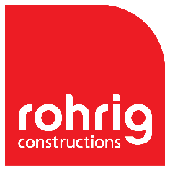 Rohrig Work Health & Safety (WHS)

Work Health & Safety Tools
Adhere to Rohrig’s WHS plan at all times
Permanent on-site management ensuring that Health and Safety requirements are met.
Management of safety requirements through Procore.

Requirements
All workers on site to be inducted by Rohrig and have at least a Whitecard: Non-negotiable.
All works on site to have a Working With Children Check: Non-negotiable.
Minimum PPE (Hard hat, Hi-vis, and Boots): Non-negotiable
Visitor to be signed in and accompanied by an inducted person.

Site Rules
All workers to always conform to WWCC requirements.
PPE to always be worn.
All workers to be inducted and signed into their Safework Method Statement
Management of unnecessary noise pollution.
No smoking on site.
No swearing.

Rohrig Safety Initiatives
Daily prestart meetings to discuss high risk works to be carried out along with mitigation plans.
Site Manager/General Foreman daily visual inspection and monitoring.
Weekly site safety inspections completed by Site Manager.
Task observations to be completed every fortnight.
Project Manager safety inspection completed fortnightly.
Toolbox talk at least evert two weeks.
Oversight Consulting (3rd Party inspections monthly)
Leadership site visit inspections completed 3 monthly.

